Leap To

Operations Manual
Leap To
What you need to do.
Leap To
What you need to do.
Leap To
What you need to do.
Leap To
What you need to do.
Leap To
What you need to do.
Leap To
What you need to do.
Leap To
What you need to do.

A Health Quest Inc. Product
Copyright © 2007 Health Quest Inc.

Table of Contents
Table of Contents 2
Part I 4
Introduction 4
Starting Up 4
Program Icons 4
Workgroup Administrator 4
Compact/Repair Icons 5
Leap To Icon 5
Leap To Help 5
Getting Started 6
Initial Setup 6
Ongoing Steps 6
Part II 7
Program Definitions and Fundamentals 7
Part III 9
Main Menu 9
Part IV 10
Maintenance Menu 10
Work Order Entry 11
Equipment 14
Maintenance Lists 16
Work Order Reports 17
Equipment Reports 24
Part V 27
Responsibility Tickler Menu 27
Responsibility Assignment Entry Form 28
Item Types 31
Responsibility Completion Entry 33
Outstanding Tickler Review 34
Responsibility Completion Lists 38
Responsibilities Completed Count 40
Part VI 43
Resident and Employee Menu 43
Resident Information Form 43
Resident Face Sheet 48
Resident Discharge 49
Employee Information 50
Part VII 53
Facility Options Menu 53
Software Options 54
Misc Items and Designations 55
Room Plan 57
Rooms Assigned by Unit Designation 58
Resident Lease Field Options 59
Security Options 62
Option Menus 66
Sort Options Menu 66
Advanced Options 67
Table of Exhibits 68

Part I

Introduction
Leap To is a software program, which allows key staff and administrators to define and monitor the responsibilities of a facility, including maintenance issues, and tasks associated with residents, employees, units, equipment, and miscellaneous items. Although the complexity of providing long-term care has generally resulted in the creation of an “Operations Manual,” this manual is usually written and is commonly too exhaustive to be readily accessible to employees in a practical manner. Leap To is the tool that makes the responsibilities of the “Operations Manual” real; through translation into action or tasks, which are to be accomplished by a designated staff person or resident, at a designated time or within a designated time frame.

Starting Up
To open the program, move the cursor on top of the Leap To icon and double-click. You will now need to supply your "NAME" and "PASSWORD;" click OK. Remember that your password is case sensitive; if your password is in uppercase letters, you must key it in that way.
When the hourglass appears, it is a sign that the computer is processing a series of instructions. Do not click the mouse or press any keys while the hourglass is running; the computer will remember these entries and attempt to execute them.

Program Icons
During Leap To installation, the program creates an icon group that helps manage your new program. Double clicking on an icon carries out the instructions associated with that icon. For example, double clicking on the Leap To icon will open Leap To. The program group contains the following five icons: Leap To, Workgroup Administrator, Repair Leap To, Repair Leap To Data, and Leap To Help.

Workgroup Administrator
This icon allows the user to join a different workgroup or create a new workgroup. Double clicking on the icon opens a dialog box that shows the user where the program’s system database is located.

Workgroup
A workgroup is a group of users in a multi-user, networked environment who utilize the same data and the same system database.

System Database
A system database is a database file that contains the security and system options for the program. This file is usually called “system.mda”. [Note: Since all of your users should be in the same workgroup, this icon should only be used if the program cannot locate your system database (usually “system.mdw”)].

Compact/Repair Icons
Over time, as the user makes changes to the program, file storage can become fragmented. Compacting the program repairs the program making the database program smaller and often results in improved performance. For these reasons, it’s important to compact your program periodically. Sometimes, if there is a power failure, program crash, or the user simply turns off the computer without exiting properly; the program database can become corrupted. If the database becomes corrupted enough, the users will not be able to access the program. Double clicking on the Repair Leap To Data compacts and repairs the data, while the Repair Leap To compacts and repairs the data manipulation objects. (Typically, it’s the data that is most likely to become fragmented or corrupted.)

Leap To Icon
Double click this icon to open Leap To. Enter your name and password, and then click OK. Remember that your password is case sensitive - if your password is in uppercase letters, you must key it in that way.

Leap To Help
Double clicking this icon will display the Help Contents of the resident care on-line help file. Within the program, this help file is context sensitive (meaning the Help File will open to the topic that the cursor is resting upon) and can be accessed by pressing the F1 key at any time. The Leap To help file provides an easy way to discover how different pieces of the Leap To program work. Clicking on a highlighted or underlined word or phrase in the Help File then will jump you to that particular topic. You can use the SEARCH feature to search for a particular topic for information. The BACK button sends the user back to the last topic he/she accessed in the current help session. The History button displays a list of all topics viewed in the current help session in the order accessed. To jump back to the Help Contents, click on the Contents. You can print a topic by using the File pull down menu, or learn how to use on-line help and its features by using the help menu. Click the CLOSE button to exit help.

Getting Started
Once Leap To has been installed, use this section as a guide to setting the program up for your facility.

Initial Setup
1. Enter facility room numbers in “Room Plan” form.
2. Complete Software Options.
3. Define Unit Designations in “Rooms by Unit Designations.”
4. Define Lease Fields you would like to track for residents, and specify which Fields you’d like to have shown on the Resident Face Sheet.
5. Set up your Security.
6. Enter all current Employees in Employee Information.
7. Enter all current Residents using the “Adding New Resident” form.
8. Enter all current equipment using the “Equipment” form.
9. Enter any additional miscellaneous items you desire to track through the “Miscellaneous Items and Designations” form.
10. Enter Responsibilities in “Responsibility Assignment Entry” form.

Ongoing Steps
- Enter tasks as completed in Responsibility Completion Entry.
- Enter new Employees as hired.
- Enter new Residents as leases are signed.
- Enter new Equipment as installed.
- Enter and complete new Work Orders as they arise.
- Enter new Responsibilities in “Responsibility Assignment Entry” form.

Part II

Program Definitions and Fundamentals

Tickler
In Leap To, the word “tickler” refers to a reminder system, or a convenient way to remind staff of responsibilities and the deadlines for their completion. The Outstanding Tickler Review reports summarize outstanding responsibilities/tasks through a given date or date range. Throughout this manual, the words “responsibility”, “duty” and “task” are interchangeable.

Buttons
Throughout the program, you will encounter gray rectangles called “buttons” (see Exhibit 1.) Each of these buttons corresponds to a form, report or particular operation. You can open the form or report or perform the desired operation by moving your mouse to place the arrow on the button, and clicking once.
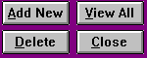
Exhibit 1: Buttons

Fields
Throughout Leap To, you will encounter fields (see Exhibit 2.), which allow you to enter information into the program. To enter information you simply move the cursor to the desired field and click with your mouse; a cursor will appear and you can type in the space provided.
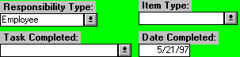
Exhibit 2: Fields
Some fields provide a list box (distinguished with a down arrow to the right of each white rectangle, Exhibit 2). List boxes allow you to select from an already existing list of possible entries. In Exhibit 2, the field “Responsibility Type” is a list box; you select from the choices provided when you click on the arrow. “Date Completed” is an example of a default field; the program supplies a probable entry, such as the current date, but allows you to change the entry.

Filters
Filters are categories by which you can limit data presented in a report. To initiate a filter, click on the circle to the left of the filter option; a list box will appear. Now click on the down arrow and highlight the specific filter criteria you want to use with the cursor and click again. Once you have selected the filter criteria, click on the FILTER button to refine the report. For example, on the Outstanding Responsibilities Tickler review, all outstanding responsibilities are detailed. You may want to view only the uncompleted employee evaluations; you can do so by selecting the filter “Responsibility Item” and highlighting the item “Employee Evaluation”. To view all records again, click the UNFILTER button. Several filters can be used in combination to further limit the data viewed. For example, the filter selections in Exhibit 3 would result in a list showing only data related to Staff Trainings that have been completed in the Food Service Department.
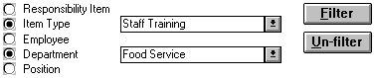
Exhibit 3: Filters

Part III

Main Menu
The main menu screen opens when you enter the program. From the “Main Menu,” you can access all the other menus in Leap To by selecting the desired menu button. You can exit the program by clicking on the EXIT LEAP TO button. Only users belonging to the coordinators security group can access the Facility Options Menu.

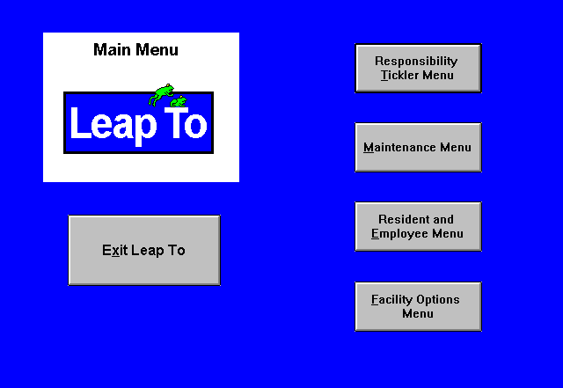
Exhibit 4: Main Menu

Part IV

Maintenance Menu
The Maintenance Menu is comprised of five primary maintenance forms and reports. Each of the five rectangular gray buttons on the Maintenance Menu corresponds to a maintenance form or report. Click on the gray buttons to open specific forms and reports.

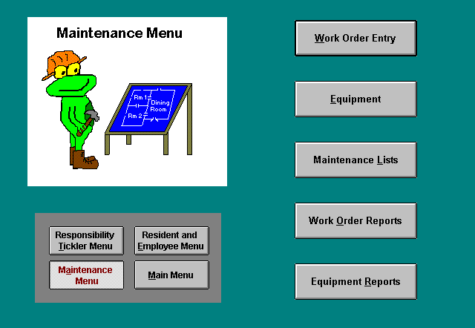

Work Order Entry
With this form you will define and complete your facility’s work orders. The Work Order Entry form is divided into three main sections: top (white), left (blue) and right (yellow). The top section contains the work order #, the search list, and buttons. The left and right sections correspond to the initial work order entry (blue) and work order completion information respectively (yellow).

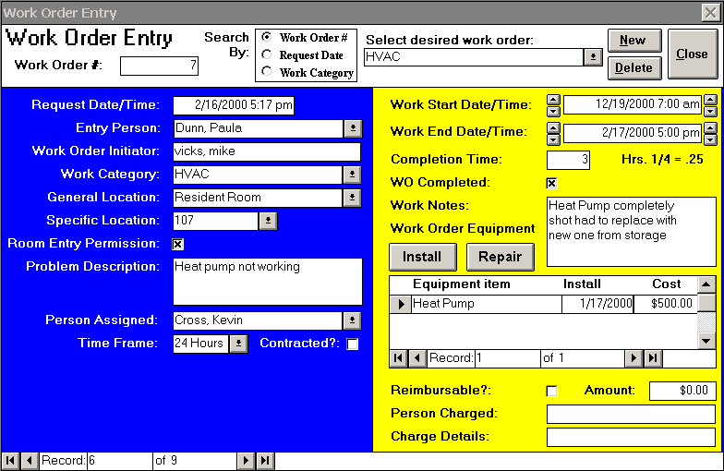
Exhibit 5: Work Order Entry

Work Order Entry: Top Section
By default, the form goes to a new work order upon opening.
Work order #: Each new work order is automatically assigned a work order # once you begin to enter information into the form.
Select desired work order: By clicking the down arrow to the right of this box, user may review a list of existing work orders. To view or edit an existing wok order: select the desired item from the box, place the cursor on the desired work order and click once. You can change how the search box is sorted by selecting one of the three “Search By” options (work order #, request date, or work category).
NEW: Clicking this button supplies user with a blank form to add a new work order. You define the work order by supplying necessary information in the designated fields.
DELETE: Clicking this button allows the user to delete a work order from the program. The delete function permanently removes that work order from the program and should be used only for mistakes. Do not delete old work orders just because they have been completed.
CLOSE: Clicking this button closes the form and returns the user to the Maintenance Menu.

Work Order Entry: Blue Section
The left blue section of the work order entry form allows you to enter the initial work order information by defining the scope of the work order.
Request Date/Time: This date and time field should reflect the date/time that the work order request was received. The current date/time is entered automatically by default. Required field.
Entry Person: The person initially entering the work order should select their name from this list of the facility’s current employees. Required field.
Work Order Initiator: Enter the name of the person who initiated the work order. This person could be a resident, family member, employee, etc… Required field.
Work Category: Choose from a list of general categories (such as Carpentry or Plumbing) used to categorize your work orders. Choosing the ‘Add New/Edit’ item from this list opens the “Work Categories” form, which allows you to create or edit your work categories. Required field.
General Location: Select the general location of where the work order will take place. Choosing the ‘Add New/Edit’ item from this list opens the “General Locations” form, which allows you to create or edit the general locations. Required field.
Specific Location: Select the specific location of where the work order will take place. Choosing the ‘Add New/Edit’ item from this list opens the “Specific Locations” form, which allows you to create or edit the specific locations. Required field.
Room Entry Permission: Mark this box when the resident has given permission to perform a work order in their room even when they are not present. Permission must be obtained for each room entry.
Problem Description: Describe the work that needs to be performed.
Person Assigned: select the employee’s name from the list who will be completing or overseeing the work order. Required field.
Time Frame: Select the work order’s urgency from three possible time frames: ASAP, within 24HRs, within 72 HRS. Required field.
Contracted?: Mark this box if an outside contractor will perform the work order.
Contractor Company: For contracted work orders enter the outside contractor company. Choosing the ‘Add New/Edit’ item from this list opens the “Contractors” form, which allows you to create or edit contractor information.
Contractor Name: Type in the name of the contractor performing the job.
Contractor Charge: Enter the total cost of the contracted work.
Contractor Labor Time: Enter the labor time the work order required of the contractor in hours. For example, an hour and a half job would be entered as 1.5.

Work Order Entry: Yellow Section
The right yellow section of the work order entry form allows you to complete the work order information once the work order is finished.
Work Start Date/Time: Enter the date/time the work order was started. When you click in this field the current date and time will be entered automatically. Up and down arrow boxes have been added to each side of this fields to adjust the date and time accordingly. For example, each click of the up arrow to the left of work start date/time will add one day to the work start date, while each click of the down arrow will subtract one day. Using the up and down arrows to the right of the fields, will add (up arrow) or subtract (down arrow) one hour for each mouse click. These additions should save you time from entering the date and times from the keyboard.

Work End Date/Time: Enter the date/time the work order was completed. See work start date/time above for tips to save time entering the correct work end date/time.

Completion Time: Enter the total labor time the work order required in hours. For example, if a work order required labor from 8am to 10am on Friday and from 3pm to 5:15pm on Monday the completion time would be entered as 4.25 hours.
WO Completed: Mark this box only when the work order has been completed. Until this box is marked the work order will appear on the “Outstanding Work Orders” form.
Work Notes: utilize this field to enter any additional information about the work order.
INSTALL Button: Use this button when you are installing new equipment in the course of a work order. Clicking this button opens the “Equipment” form, where you should fill out the appropriate fields. Once all your equipment you’ve installed during the work order is entered and the “Equipment” form closed, the installed equipment will appear on the work order equipment subform right under this button.
REPAIR Button: Use this button when you are repairing an existing piece of equipment in the course of a work order (Existing in this case means you have entered the piece of equipment through the Equipment form at some point.) Clicking this button opens the “Work Order Equipment” form. Select from the drop down list the piece of equipment being repaired and click on the ADD button. The repaired piece of equipment will now appear on the work order equipment subform right under this button.
Work Order Equipment Subform: This subform (located under the INSTALL and REPAIR buttons) details the equipment item, install date, and cost of all equipment items either installed or repaired during the course of the current work order. Clicking of the equipment item field will open the Equipment form to the selected piece of equipment.
Reimbursable?: Mark this box if any of the labor, equipment, etc. is reimbursable to the facility.
Reimbursable Amount: Enter the dollar amount of any reimbursable charges.
Person Charged: Enter the name of the person who the facility should bill for the reimbursable charges.
Charge Details: Enter a description of what the charged person will be billed for.

Equipment
This form is where you enter all of the equipment you wish to track for your facility. If the equipment is installed during a work order, this form should be opened utilizing the INSTALL button on the “Work Order Entry” form. To review/edit existing equipment, open this form by pressing the EQUIPMENT button on the Maintenance Menu.
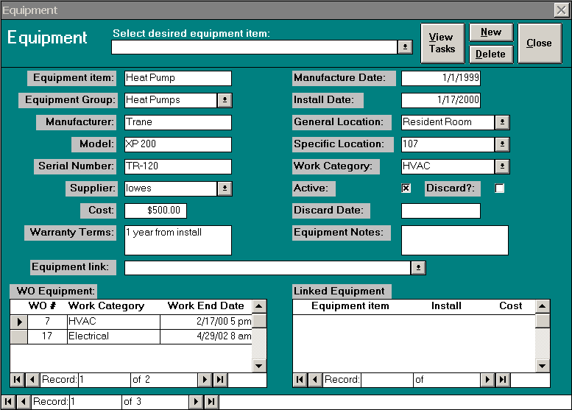
Exhibit 6: Equipment
Equipment Item: Enter the name of the piece of equipment. Required field
Equipment Group: Select from this list the equipment group in which this equipment belongs. Choosing the ‘Add New/Edit’ item from this list opens the “Equipment Groups” form, which allows you to create or edit the equipment groups. Required field.
Manufacturer: Type in the company who manufactured the equipment.
Model: Enter the model of the equipment.
Serial Number: Type in the equipment’s serial number if applicable.
Supplier: Enter from whom the equipment was purchased. Choose the appropriate supplier from the drop down list. Choosing the ‘Add New/Edit’ item from this list opens the Suppliers form, which allows you to create a new supplier or edit an existing one. This form allows you to enter information about the supply companies your facility utilizes.
Cost: Enter the total cost of the equipment. Required field.
Warranty Terms: Briefly describe the terms of the warranty.
Equipment link: If this equipment is a component of a greater piece of equipment, select the greater piece of equipment from the equipment link drop down list. For example, if the equipment being entered is a compressor for a refrigerator, select the appropriate fridge from the list in this field.
Manufacture Date: Enter the equipment’s manufacture date. If this is unknown use the purchase date.
Install Date: Enter the date the equipment is installed. Required Field.
General Location: Select the general location of where the equipment is installed. Choosing the ‘Add New/Edit’ item from this list opens the “General Locations” form, which allows you to create or edit the general locations. Choosing 'Resident Room' from this list changes the specific location list to contain your facility's room numbers. Required field.
Specific Location: Select the specific location of where the equipment is installed. Choosing the ‘Add New/Edit’ item from this list opens the “Specific Locations” form, which allows you to create or edit the specific locations. Required field.
Work Category: Choose from a list of general categories (such as Carpentry or Plumbing) used to categorize your work orders. Choosing the ‘Add New/Edit’ item from this list opens the “Work Categories” form, which allows you to create or edit your work categories. Required field.
Active: Unmark this box only when the equipment is not installed. Required field.
Discard?: Mark this box when you discard the equipment.
Discard Date: Enter the date you discarded the equipment.
Equipment Notes: utilize this field to enter any additional information about the equipment.
WO Equipment Subform: This subform details the work order #, work category, and work end date all work orders during which this equipment was either installed or repaired. Clicking on the work order # field, will open the “Work Order Entry” form to the selected work order.
Linked Equipment Subform: This subform details the equipment item, install date, and cost of all the entered equipment components linked to the current piece of equipment. These links are defined by using the equipment link field. Clicking on the equipment item, will take you to that equipment’s information.
After the “Equipment” form is completed, click the CLOSE button at the top form, or, if you want to add another equipment item, click the ADD button again. To edit or review equipment items, select an equipment item from the drop-down list under ‘Select desired equipment item’. Click the VIEW TASKS button to view a summary report of the tasks you have completed regarding this equipment item. The “Equipment: Completed Tasks” form details the finish date, task completed, task type, and comments. Tasks are assigned in the “Responsibility Assignment Entry” form and entered when completed in the “Responsibility Completion Entry” form. Equipment tasks are assigned to cover your preventative equipment maintenance as opposed to work orders, which represent as needed repairs and labor. If you wish to delete the current equipment item record, click the DELETE button. Only use the DELETE button to delete erroneous equipment items. Never use the DELETE when discarding equipment. Mark the discard box, unmark the active box, and enter the discard date instead.

Maintenance Lists
An option box will appear after selecting the Maintenance Lists button on the Maintenance Menu. The maintenance list forms (Contractors, Equipment Groups, General Locations, Specific Locations, Suppliers, and Work Categories) contain information utilized in completing the “Work Order Entry” and “Equipment” forms. Open the desired maintenance list by simply clicking on your desired selection. Once in your selected maintenance list, press the NEW button to go to a blank record and enter the pertinent information of the new supplier, contractor, equipment group, etc. On the other hand, to edit or review an existing list item, select the item from the drop-down list or scroll to the desired item. The Suppliers and Contractors lists have a VIEW button that allows you to view and/or print a complete list of your contractors and suppliers respectively. Press CANCEL to return to the Maintenance Menu.
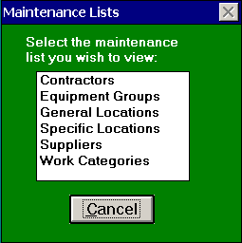
Exhibit 7: Maintenance List

Work Order Reports
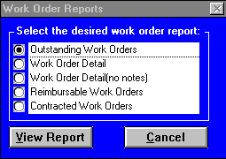
This form provides you with reports that examine your facility’s work orders. Specifically, it allows you to open the following five reports “Outstanding Work Orders,” “Work Order Detail,” “Work Order Detail (no notes),” “Reimbursable Work Orders,” and “Contracted Work Orders.” Pressing the VIEW REPORT button will open the specified report for viewing and/or printing. Clicking the CANCEL button will close this form and return the user to the Maintenance Menu.
Exhibit 8: Work Order Reports
Outstanding Work Orders
This report lists all the work orders that are currently uncompleted sorted by time frame and entry date/time giving you a good snapshot of your facility’s most pressing maintenance needs. Users can print individualized Outstanding Work Order forms for each staff person assigned tasks. This will be helpful for those properties with multiple employees completing their work orders. To have an outstanding work order drop off this list, mark the WO completion box on the “Work Order Entry” form when the work order is completed. Pressing on the WO DETAIL button will show more detailed information by opening the “Work Order Entry” form to the selected work order. Clicking the PRINT button will print this report, while the CLOSE button returns you to the “Work Order Reports” form. The “Outstanding Work Orders” report allows the use of the Sort Options Menu.

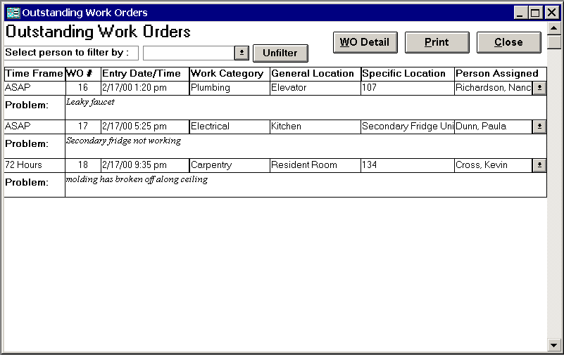
Exhibit 9: Outstanding Work Orders

Work Order Detail
This form includes all the work orders entered through the “Work Order Entry” form. Instead of reviewing a single work order this form allows you an overview of your entire facility’s work orders. Through the filter options and Sort Options menu, you are able to filter and sort your work orders in a myriad of ways. This form contains the following fields:
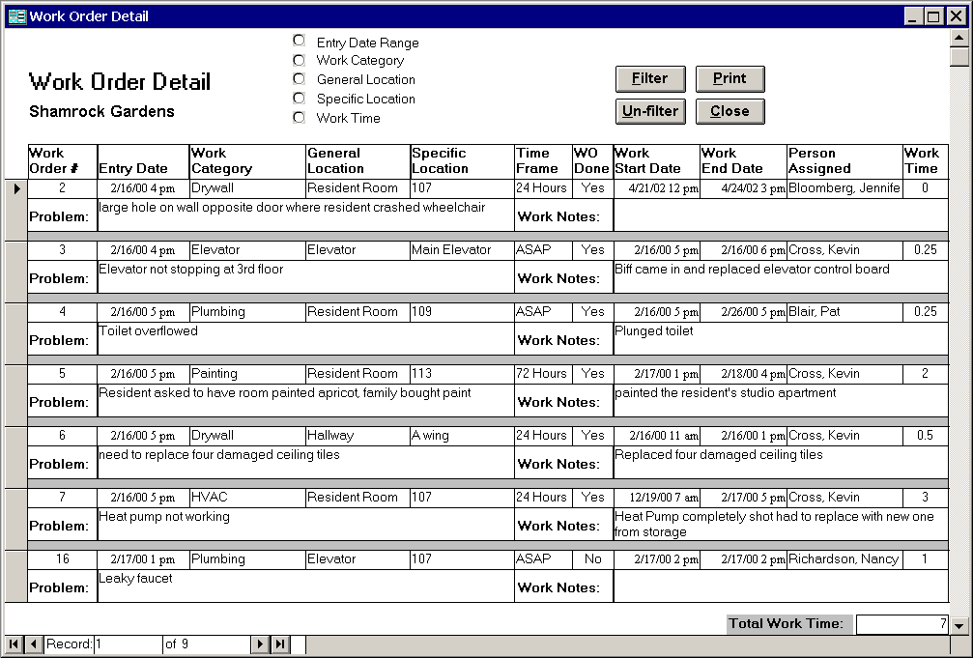
Exhibit 10: Work Order Detail
Work order #: unique number used to identify a work order.
Entry Date/Time: the date/time that the work order request was received.
Work Category: the general category of the work order such as Carpentry or Plumbing.
General Location: general place of where the work order took place.
Specific Location: specific place of where the work order took place
Time Frame: reflects the work order’s urgency from three possible time frames: ASAP, within 24HRs, within 72 HRS.
WO Done: identifies whether or not the work order has been completed.
Work Start Date/Time: date/time the work order was started.
Work End Date/Time: date/time the work order was completed.
Person Assigned: the employee who completed or oversaw the work order.
Work Time: the total labor time the work order required in hours.
Problem Description: description of what work needed to be performed.
Work Notes: contains any additional information about the work order.

Filter Options
The filter options provide an efficient way to extract specific information from the work orders. To initiate a filter, click on the option button () to the left of the desired filter selection to open a list of choices. (For example, choosing the work category option opens a list of all your work categories). Next, select the desired item from the list. Then you can either choose another filter selection to refine your list even more, or process the records with the current selection by clicking the FILTER button. For example, suppose you wanted to know which plumbing work orders took between 2 to 4 hours. Simply click the work category option button and choose ‘Plumbing’ from the list. Next, choose the work time filter and enter a range of 2 to 4. Pressing the FILTER button reduces the work orders to plumbing orders taking between 2 to 4 hours. Click the UNFILTER button to show all the work orders again. The form contains the following filters:

Entry Date Range: enter the date range you wish to filter for.

Work Category: list contains all the work categories (such as Plumbing or Carpentry) entered in the “Work Categories” form.
General Location: list of general locations (such as resident room) from the “General Locations” form, which allows you to create or edit the general locations.
Specific Location: list of specific locations from the “Specific Locations” form, which allows you to create or edit the specific locations.
Work Time: enter a number range in hours to filter by the work time.
You can print the “Work Order Detail” by clicking the PRINT button or close it by clicking the CLOSE button. This form allows the use of the Sort Options Menu.

Work Order Detail (no notes)
This report contains the exact same information and filters as “Work Order Detail” except it excludes the work order problem description and work notes making it a much more compact report. See “Work Order Detail” above for report detail.

Reimbursable Work Orders
This report contains all the work orders that have reimbursable charges. Through the filter options and Sort Options menu, you are able to filter and sort your reimbursable work orders. This form contains the following fields:

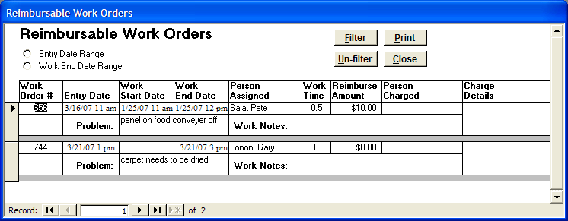
Exhibit 11: Reimbursable Work Orders
Work order #: unique number used to identify a work order.
Work Start Date/Time: date/time the work order was started.
Work End Date/Time: date/time the work order was completed.
Person Assigned: the employee who completed or oversaw the work order.
Work Time: the total labor time the work order required in hours.
Reimbursable Amount: the dollar amount of any reimbursable charges.
Person Charged: the name of the person who the facility should bill for the reimbursable charges.
Charge Details: description of what the charged person will be billed for.
Problem Description: description of what work needed to be performed.
Work Notes: contains any additional information about the work order.

Filter Options
The filter options provide an efficient way to extract specific information from the reimbursable work orders. To initiate a filter, click on the option button () to the left of the desired filter selection and enter your date range. Then you can either choose another filter selection to refine your list even more, or process the records with the current selection by clicking the FILTER button. Click the UNFILTER button to show all the work orders again. The form contains the following filters:

Entry Date Range: enter the entry date range you wish to filter for.
Work End Date Range: enter the work end date range you wish to filter for.

You can print the “Reimbursable Work Orders” report by clicking the PRINT button or close it by clicking the CLOSE button. This form allows the use of the Sort Options Menu.

Contracted Work Orders
This report contains all the work orders performed by contractors. This form contains the following fields:
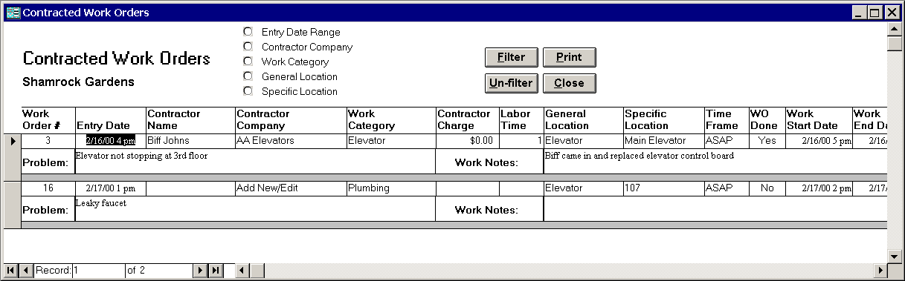
Exhibit 12: Contracted Work Orders
Work order #: unique number used to identify a work order.
Entry Date: date/time the work order was received.
Contractor Company: the outside contractor company who helped perform the work order.
Contractor Name: name of the contractor performing the job.
Contractor Charge: total cost of the contracted work.
Contractor Labor Time: the labor time the work order required of the contractor in hours
Work Category: the general category of the work order such as Carpentry or Plumbing.
General Location: general place of where the work order took place.
Specific Location: specific place of where the work order took place.
Time Frame: reflects the work order’s urgency from three possible time frames: ASAP, within 24HRs, within 72 HRS.
WO Done: identifies whether or not the work order has been completed.
Work Start Date/Time: date/time the work order was started.
Work End Date/Time: date/time the work order was completed.
Work Time: the total labor time the work order required in hours.
Problem Description: description of what work needed to be performed.
Work Notes: contains any additional information about the work order.

Filter Options
The filter options provide an efficient way to extract specific information from the work orders. To initiate a filter, click on the option button () to the left of the desired filter selection to open a list of choices. (For example, choosing the work category option opens a list of all your work categories). Next, select the desired item from the list. Then you can either choose another filter selection to refine your list even more, or process the records with the current selection by clicking the FILTER button. For example, suppose you wanted to know which plumbing work orders took between 2 to 4 hours. Simply click the work category option button and choose ‘Plumbing’ from the list. Next, choose the work time filter and enter a range of 2 to 4. Pressing the FILTER button reduces the work orders to plumbing orders taking between 2 to 4 hours. Click the UNFILTER button to show all the work orders again. The form contains the following filters:

Entry Date Range: enter the date range you wish to filter for.

Work Category: list contains all the work categories (such as Plumbing or Carpentry) entered in the “Work Categories” form.
General Location: list of general locations (such as resident room) from the “General Locations” form, which allows you to create or edit the general locations.
Specific Location: list of specific locations from the “Specific Locations” form, which allows you to create or edit the specific locations.
Work Time: enter a number range in hours to filter by the work time.
You can print the “Contracted Work Orders” report by clicking the PRINT button or close it by clicking the CLOSE button. This form allows the use of the Sort Options Menu.

Equipment Reports
This form provides you with reports that examine your equipment. Specifically, it allows you to open either “Equipment Detail” or Equipment Detail (no notes).” Pressing the VIEW REPORT button will open the specified report for viewing and/or printing. Clicking the CANCEL button will close this form and return the user to the Maintenance Menu.
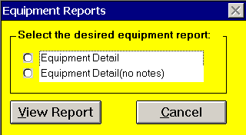
Exhibit 13: Equipment Reports

Equipment Detail
This form includes all equipment entered through the “Equipment” form. Instead of reviewing a single equipment item this form allows you an overview of all your facility’s equipment. Through the filter options and Sort Options menu, you are able to filter and sort your equipment in a myriad of ways. Equipment Detail is filtered into one of four equipment categories: active, inactive, discarded, or all. The default is active equipment. Note: when reviewing discarded equipment, discard date replaces the manufacture date. This form contains the following fields:
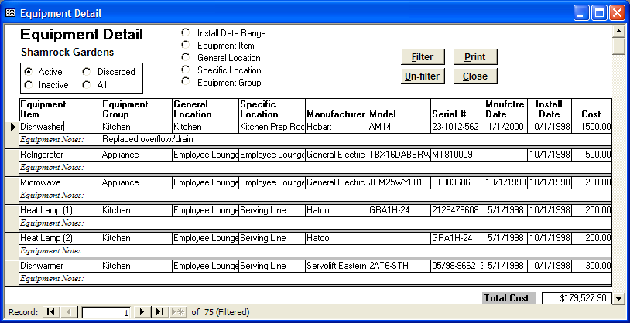
Exhibit 14: Equipment Detail
Equipment Item: name of the piece of equipment
Equipment Group: general group in which this equipment belongs such as Heat Pump.
General Location: general place of where the work order took place.
Specific Location: specific place of where the work order took place
Manufacturer: company who manufactured the equipment.
Model: the model of the equipment.
Serial #: the equipment’s serial number.
Manufacture Date: the equipment’s manufacture date.
Install Date: date the equipment is installed. Required Field.
Cost: Enter the total cost of the equipment. Required field.
Equipment Notes: any additional information or notes about the equipment.

Filter Options
The filter options provide an efficient way to extract specific information from the equipment items. To initiate a filter, click on the option button () to the left of the desired filter selection to open a list of choices. (For example, choosing the equipment group option opens a list of all your equipment groups). Next, select the desired item from the list. Then you can either choose another filter selection to refine your list even more, or process the records with the current selection by clicking the FILTER button. Click the UNFILTER button to show all the equipment again. These filters are utilized in conjunction with main equipment category filter. The form contains the following filters:
Install Date Range: enter the install date range you wish to filter for.
Equipment item: list contains all the equipment items.
General Location: list of general locations (such as resident room) from the “General Locations” form, which allows you to create or edit the general locations.
Specific Location: list of specific locations from the “Specific Locations” form, which allows you to create or edit the specific locations.
Equipment Group: list of equipment groups (such as Heat Pump) from the “Equipment Groups” form, which allows you to create or edit the equipment groups.
You can print the “Equipment Detail” by clicking the PRINT button or close it by clicking the CLOSE button. This form allows the use of the Sort Options Menu.

Equipment Detail (no notes)
This report contains the exact same information and filters as “Equipment Detail” except it excludes the equipment notes making it a much more compact report. See “Equipment Detail” above for report detail.
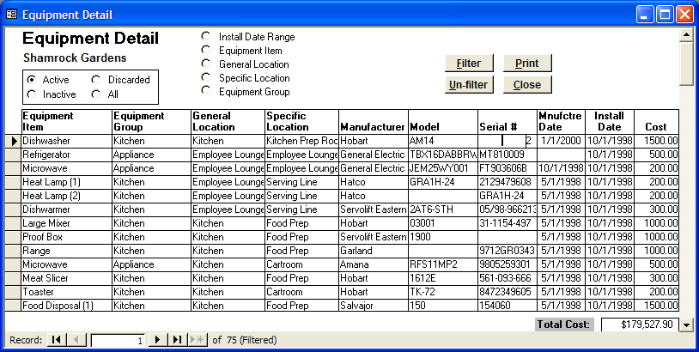
Exhibit 15: Equipment Detail (no notes)

Part V

Responsibility Tickler Menu
The Responsibility Tickler Menu is comprised of five primary forms and reports. Each of the five rectangular gray buttons on the Responsibility Tickler Menu corresponds to a form or report. Click on the gray buttons to open specific forms and reports.
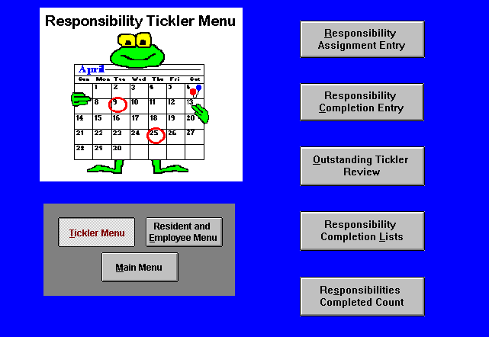
Exhibit 16: Responsibility Tickler Menu and Buttons

Responsibility Assignment Entry Form
With this form you will define and assign responsibilities and choose tickle options for those responsibilities. The Responsibility Assignment form is divided into three sections: top, middle and bottom, which correspond to its three primary functions: creating/editing responsibilities, assigning responsibilities, and setting responsibility tickle options (the dates for responsibility notification and completion).

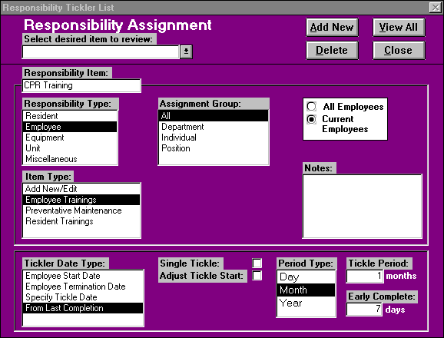
Exhibit 17: Responsibility Assignment Form
Exhibit
Exhibit
Exhibit
Exhibit
Exhibit
Exhibit
Exhibit
Exhibit
Exhibit 18
Exhibit

Creating and Editing Responsibilities
The top section of the responsibility form allows you to create a new responsibility and to edit or delete existing responsibilities.
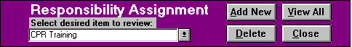
Exhibit 19: Top Section: Responsibility Assignment Form
Select desired item to review: By clicking the down arrow to the right of this box, user may review a list of existing responsibilities. To view or edit an existing responsibility: select the desired item from the box, place the cursor on the desired responsibility and click once. All changes will automatically be saved.
Add New: Clicking this button supplies user with a blank form to add a new responsibility. You define the task for the community by supplying necessary information in the last two sections of the “Responsibility Assignment” form. All new responsibilities must be added with the ADD NEW button. DO NOT try to write over the current screen; this will permanently alter an existing responsibility.
View All: Click on this button to view or print a summary report of all existing responsibilities broken out into columns by the assignment form criteria: responsibility type, responsibility item, item type, assignment group, specific assignment, tickle start, tickle period, early complete days, and single tickle status. To single out data on the Responsibility List Report, select from the following filter options: responsibility type, responsibility item, item type, assignment group, or single tickle and click on the FILTER button.
Delete: Click this button to allow the user to delete a responsibility from the program. The delete function removes that responsibility from the program and should be used with care.
Close: Clicking this button closes the form and returns the user to the main menu.

Assigning Responsibilities
The middle section of the Responsibility Assignment form allows you to assign a responsibility item and type to a particular group or individual.
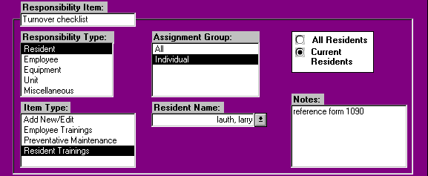
Exhibit 20: Middle Section: Responsibility Assignment Form
Responsibility Item: When adding new or editing existing responsibility assignment records, enter the specific name of the responsibility, for example “CPR Training”.
Responsibility Type: Choose one of five facility categories associated with a responsibility: resident, employee, equipment, unit, or miscellaneous. For example, the Responsibility Items-- “Replace Carpeting: Hallways” and “CPR Training”-- fall into the “Employee” category, as both tasks should be assigned to specific employees or departments. Conversely, “Room Painting” should be categorized as a “Unit” responsibility, so you can assign that task either for all units, a specific unit, or a unit designation.
Assignment Group: Choose from a list of general categories used to assign responsibilities. The choices listed under “Assignment Group” will correspond to the Responsibility Type chosen (Resident, Employee, Equipment, Unit, or Miscellaneous). For example, if you choose to assign an Employee responsibility, the form supplies you with the Group choices: All, Department, Position, or Individual. You will also need to choose either “All Employees” (past and present) or “Current Employees”. CPR Training, for example, would apply only to “Current Employees” and would likely fall under the assignment group “Department”. Once this assignment group is selected, the form automatically opens any corresponding field(s), allowing you to further define the assignment (See Exhibit 29).
Notes: utilize this field to enter any additional information about the responsibility assignment.
Item Type: Select the general category, which describes a responsibility item, for example the responsibility item “CPR Training” falls under the general type, “Staff Training.” Choosing the ‘Add New/Edit’ item from this list opens the “Item Types” form, which allows you to create or edit item types.

Item Types
View this form by choosing the “Add New/Edit” item from the “Item Types” field in the middle section of the “Responsibility Assignment Entry” form. This form allows the marketing associate to add and edit item types. Each item type consists of two fields: ‘Item Type,’ and ‘Responsibility Type.’ To add a new item type click on the NEW button and enter the item type name. Be sure to select the responsibility type, which corresponds to the item type. Choose from one of following four responsibility categories: Resident, Employee, Equipment, Unit, or Miscellaneous. Users utilize the item types for filtering and sorting flexibility on the reports. To delete an item type, select the item type and then click the DELETE button. Click the CLOSE button when finished to return to the "Responsibility Assignment" form.
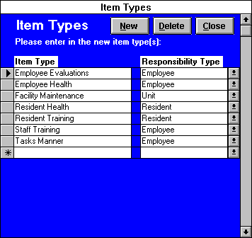
Exhibit 21: Item Types Form

Setting Tickle Options
The bottom section of the Responsibility Assignment form allows you to specify the date your program should remind you of a facility responsibility.
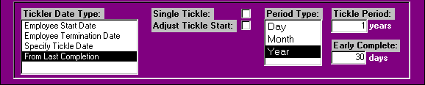
Exhibit 22: Bottom Section: Responsibility Assignment Form
Tickler Date Type: To set the Tickler Start date, choose from a default list of commonly used dates/anniversaries, such as “Employee Start Date” or select the option to “Specify Tickle Date” and enter the date in the field provided. “From Last Completion” allows the user to schedule task tickles automatically over a specified period.
Single Tickle: Click to designate the responsibility as a one-time event, such as a discharge survey. (Leap To assumes responsibilities are on going, unless this box is marked.)
Adjust Tickle Start: Click in this box to tickle you for a responsibility on an already established tickle start date plus or minus a certain number of days. For example, your facility may require an initial six months review for new employees and then yearly evaluations from the date of the initial review. (If you choose to specify the date, you will not need to use the adjust tickle option.)
Tickle Adjustment: After selecting Adjust Tickle Start, enter the number of days from the default date (such as Employee start date); you would like to be reminded to perform a task. Using the employee evaluation example, you would enter “Year” as period type and “1” as tickle period and then adjust the employee start date plus 180 days. This setup would tickle you for annual reviews using the employee start date + 180 days as the anniversary date.
Period Type: Select the desired time increment for your tickle period. Choose day, month, or year.
Tickle Period: number of periods between the tickle start date (set with Tickler Date Type or Adjust Tickle Start option) and the date the responsibility should be performed. The period lengths are based on the period type selected.
Early Complete Days: Ensures that that a record of completion is appropriately matched with the correct responsibility when the same task reoccurs with frequency. Enter the number of days prior to a responsibility’s tickler date, that a staff member can perform and record the completion of that responsibility. For example, suppose you require the Food Service Director to do a physical inventory monthly while setting your early complete days to 7. If the Food Service Director performs the inventory more than 7 days before the required tickle date, the inventory responsibility remains outstanding. If you do not want to allow early completion for a responsibility, enter “0” days.

Responsibility Completion Entry
With this form you will enter tasks as they are completed. In order to take advantage of Leap To’s responsibility completion reports, you must create a record of every task completed and the employees, residents or units associated with the completion of that task.
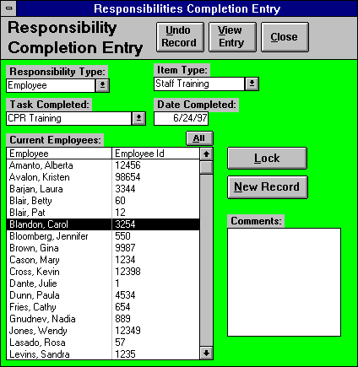
Exhibit 23: Responsibility Completion Entry
To create a completion record, select or enter the following information in the fields provided.
Responsibility Type: Click on the down arrow to choose one of five facility categories into which the completed responsibility falls: Resident, Employee, Equipment, Unit, or Miscellaneous. For example, the responsibility item “CPR Training” falls under the responsibility type, “Employee.”
Task Completed: Click on the down arrow to choose the specific responsibility completed, for example the responsibility item “CPR Training”.
Item Type: Automatically defaults to the general category which describes the “Task completed”, for example if you select the responsibility item “CPR Training” in the task completed list, item type defaults to “Staff Training”. You may select a different type if necessary. Choosing the ‘Add New/Edit’ item from this list opens the “Item Types” form, which allows you to create or edit item types.
Date Completed: This field defaults to today’s date. You may also back date completion of a task by entering the correct date in this field.
Comments: Enter any additional information you want included about the task completed.
Entry Lists: Note that Responsibility Type determines the type of list box, which appears on the Responsibility Completion Entry form. For example, selecting the responsibility type “Employee” automatically pulls up a list of current employees (as in Exhibit 32). Likewise, selecting the type “Resident”, or “Unit” pulls up a list of current residents or units, respectively. To view a list of both past and present residents and employees, click on the ALL button at the upper right hand corner of the entry box. To scroll through a list, place the cursor on the up or down arrow, click and hold with the mouse.
New Record: Supplies the user with a blank record for entering a responsibility as completed. Click on the resident name, employee, equipment item, unit, or misc. item associated with the completion of that responsibility in the list box supplied. Click NEW RECORD to move to the next responsibility completion record.
Lock: This is the most efficient way to enter completed tasks. Click this button to enter records for multiple names or unit numbers associated with the completion of the same responsibility item. For example, if the entire Nursing Department completed training, you could select that specific item under “Task Completed” and click on LOCK. Place the cursor on the name of each employee who completed the task and the program will automatically enter a new completion record for each name. To remove the entry lock, click the LOCK button once again.
View Entry: Click this button to view a summary report of the record(s) you have just entered. The Current Responsibility Entry report details task completed, item type, date completed and resident, employee, equipment, unit, or misc. item associated with that responsibility. To single out entry records for one of the five Responsibility types (Resident, Employee, Equipment, Unit, or Miscellaneous), select a type from the list box located in the upper left corner of the report. To view all records again, click the ALL button located on the upper right corner of the report. . To delete a responsibility completion record, select the appropriate record and then click the DELETE button. Press the CLOSE button to return to the Responsibility Completion Entry form.
To undo the current record entry, click the UNDO RECORD button. When you have finished entering the completion record(s), click the CLOSE button to leave the entry form and return to the Responsibility Tickler Menu.

Outstanding Tickler Review
The Outstanding Tickler Review allows you to view a report of all outstanding responsibilities through the current date, through a user-specified date, or for a specified date range (reports through a specified date only include the oldest of each responsibility assignment). For example, if you require your Food Service Director to do monthly physical inventories and he does not do one for a few months, only the first month he missed will show on the report. Conversely, outstanding responsibility reports for a specified date range will show all the undone responsibility assignments over the designated period. Using the previous example, this report will show all the Food Service Director’s missed physical inventories, not just the first. Once a responsibility is entered as completed, all undone tickles previous to that date are wiped out on both of these report types.
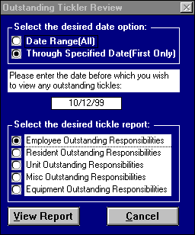
Choose from one of five responsibility type reports (Employee, Resident, Equipment, Unit, or Miscellaneous) by clicking in the circle to the left of the desired report option. Select VIEW REPORT to view the report or CANCEL to return to the main menu.
Exhibit 24: Outstanding Tickler Review Options
These reports list all the outstanding responsibilities through a specified date or date range. They detail the outstanding Responsibility Item, Item Type, Employee name, Resident name, Equipment item, Unit number, or Miscellaneous Item, Tickler Date (date the responsibility should have been performed), and other relevant information depending on the report type selected.
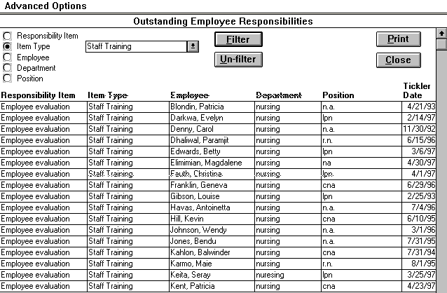
Exhibit 25: Outstanding Tickle Review: Employee Responsibilities

General Filters
You can refine your report or single out data by using the filter criteria listed at the top left corner of the report. For example, to view only the outstanding employee evaluations, click on the circle to the left of the filter “Responsibility Item”, highlight the item “Employee Evaluation”, and then click on the FILTER button. To undo a filter and view all responsibilities again, click on the UN-FILTER button. Click on “Responsibility Item” to filter by the specific name of the responsibility, or on “Item Type” to view all outstanding responsibilities in a general category. For example, outstanding Employee Evaluations and CPR Trainings appear on a report filtered by the type “Staff Training”.
[Note: Only the “Responsibility Item” and “Item Type” filters automatically appear on every Outstanding Tickler Review report; the other three filters vary, and are described under the heading Report-Specific Filters below]

Report-Specific Filters
Except for “Responsibility Item”, and “Item Type”, the filter criteria available on an Outstanding Responsibilities report will depend upon the report type selected in the option box (Employee, Resident, Equipment, Unit, or Misc. Outstanding Responsibilities). The report-specific filters are described as follows:

Employee Outstanding Responsibilities Filters
Select “Employee” to view all outstanding responsibilities associated with a specific employee, “Department” to view all outstanding responsibilities associated with that department, or “Position” to view all outstanding responsibilities associated with that position.
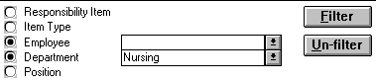
Exhibit 26: Report Specific Filters: Employee Outstanding Responsibilities

Resident Outstanding Responsibility Filters
Select “Resident Name” to view all outstanding responsibilities associated with a specific resident.

Equipment Outstanding Responsibility Filters
Select “Equipment Item” to view all outstanding responsibilities associated with a specific equipment item, or “Equipment Group” to view all outstanding responsibilities associated with the selected equipment group.

Unit Outstanding Responsibility Filters
Select “Room Number” to view all outstanding responsibilities associated with a particular room, or “Unit Designation” (a facility defined designation for a group of rooms, such as a floor or wing) to view all outstanding responsibilities associated with that designation.

Misc Outstanding Responsibility Filters
Select “Misc Item” to view all outstanding responsibilities associated with a specific misc item, or “Misc Item Designation” (a user defined designation for a group of misc items) to view all outstanding responsibilities associated with the selected misc item designation.
To print a copy of an Outstanding Responsibilities report, click on PRINT. Click on the CLOSE button to close the form and return to the main menu.

Responsibility Completion Lists
An option box will appear after selecting the Responsibility Completion Lists button on the Responsibility Tickler Menu. To view a report of all responsibilities you have entered as completed, click beside the desired report type and click on the VIEW REPORT button or CANCEL to return to the Responsibility Tickler Menu. (As with all reports in this program, choose from five report types: Resident, Employee, Equipment, Unit, or Miscellaneous)
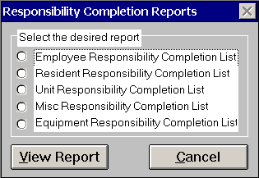
Exhibit 27: Responsibility Completion Reports: Option Box
Each Responsibility Completion List details the completed Responsibility Item, the Item Type, the Date Completed, and any Comments entered at the Responsibility Completion Entry form. Other relevant information is included depending on the report type selected.
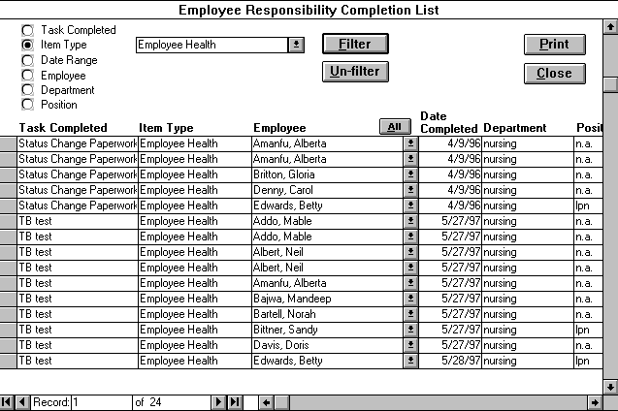
Exhibit 28: Employee Responsibility Completion List

General Filters
Select “Task Completed” to filter by the specific name of the responsibility (for example “CPR Training”), or “Item Type” to view all completed responsibilities in a general category. For example, in Exhibit 37 the responsibilities “Status Change Paperwork” and “TB Test” both appear on a list filtered by the Item Type “Employee Health”. You can also select “Date Range” and enter a time frame within which you’d like to view a list of completed responsibilities.

List-Specific Filters
The filter options available on a completed responsibilities list depend upon the list type selected in the option box (Employee, Resident or Unit Responsibility Completion List). The list-specific filters are described as follows:

Employee Responsibility Completion List Filters
Select “Employee” to view only completed responsibilities associated with that employee, “Department” to view only completed responsibilities associated with that department, or “Position” to view only completed responsibilities associated with that position.

Resident Responsibility Completion List Filters
Select “Resident Name” to view only completed responsibilities associated with that resident.

Equipment Responsibility Completion List Filters
Select “Equipment Item” to view only completed responsibilities associated with that equipment item or “Equipment Group” to view all completed responsibilities associated with the selected group.

Unit Responsibility Completion List Filters
Select “Room Number” to view only completed responsibilities associated with that unit or “Unit Designation” (defined in the Rooms By Unit Designation form) to view all completed responsibilities associated with that designation. A unit designation could refer, for example, to a group of units, such as a wing or floor.

Misc Responsibility Completion List Filters
Select “Misc Item” to view only completed responsibilities associated with that misc item or “Misc Item Designation” (defined in the Misc Items and Designations form) to view all completed responsibilities associated with that designation.
To print a copy of a Responsibility Completion List, click on PRINT. To close the report and return to the main menu, click on the CLOSE button.

Responsibilities Completed Count
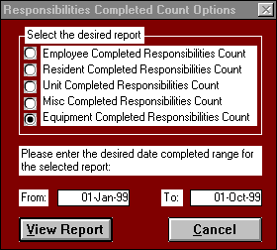
When you click the Responsibilities Completed Count button on the Responsibility Tickler Menu, this submenu will appear.
Exhibit 29: Responsibilities Completed Count Options
To view a tally of completed responsibilities, click beside the desired report type, enter a date range, and click on the VIEW REPORT button (CANCEL to returns you to the Responsibility Tickler Menu). Each Responsibilities Completed Count report shows the Responsibility Completed, the Item Type, the number of times the responsibility has been completed through the given date range, and other relevant information depending on the report type selected. The Resident report follows as an example.

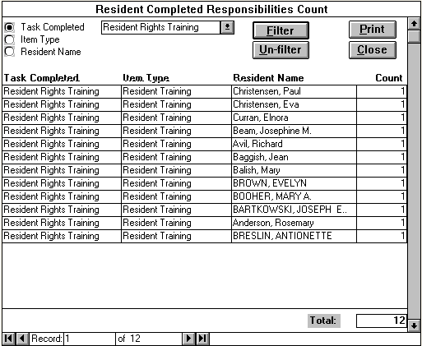
Exhibit 30: Resident Completed Responsibilities Count

General Filters
Select “Task Completed” to filter by the specific name of the responsibility (such as “Residents Rights Training”), or “Item Type” to view all completed responsibilities in a general category.

Report-Specific Filters

Employee Completed Responsibilities Count Filters
Select “Employee” to view only completed responsibilities associated with that employee, “Department” to view only completed responsibilities associated with that department, or “Position” to view only completed responsibilities associated with that position

Resident Completed Responsibilities Count Filter
Select “Resident Name” to view only completed responsibilities associated with that resident.

Equipment Completed Responsibilities Count Filters
Select “Equipment item” to view only completed responsibilities associated with that equipment item or “Equipment Group” to view only completed responsibilities associated with the desired group.

Unit Completed Responsibilities Count Filters
Select “Room Number” to view only completed responsibilities associated with that unit or “Unit Designation” to view only completed responsibilities associated with that facility-defined designation. A unit designation could refer, for example, to a group of units, such as a wing or floor.

Misc Completed Responsibilities Count Filters
Select “Misc Item” to view only completed responsibilities associated with that misc item or “Misc Item Designation” to view only completed responsibilities associated with that user-defined designation.
To print a copy of a Responsibility Completion Count, click on PRINT. To close the report and return to the main menu, click on the CLOSE button.

Part VI

Resident and Employee Menu
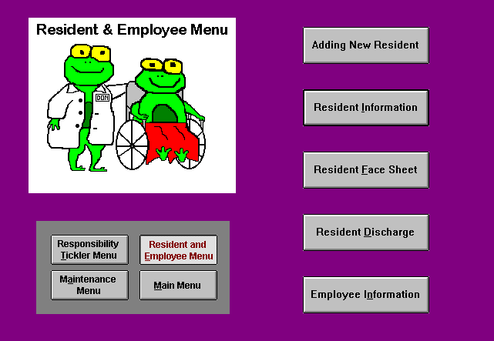
Exhibit 31: Resident and Employee Menu

Resident Information Form
This form lets you add, edit, and review resident information. To add resident information, enter the appropriate information field by field (see “Adding a New Resident” below). To edit or review current residents, select a name from the drop-down list or enter the resident’s name under ‘Select a current resident lease’. If you wish to select from a list of current and former residents, click the ALL button then enter or choose the resident name. Click the ALL button again to return to a list of only current residents (residents remain in this list until they are discharged or until lease end date.)

Adding a New Resident
To enter a new resident into Leap To, click the “Adding New Resident ” button at the “Resident and Employee” menu. The following box appears:
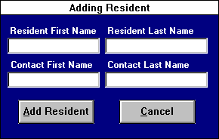
Exhibit 32: Adding New Resident
Enter the names of both the new resident and the resident’s primary contact (both names must be entered to proceed), and click the ADD RESIDENT button. A blank “Resident Information” form will open. Enter the new resident’s information according to the following field descriptions. Click the CANCEL button to return to the “Resident and Employee Menu.”
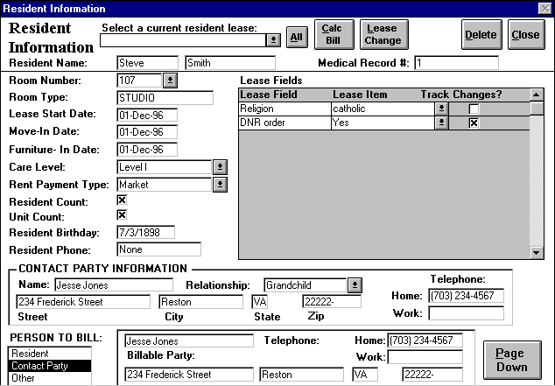
Exhibit 33: Resident Information - Page 1
Medical Record #: The resident’s medical record number, if your facility utilizes such a number to identify its residents.
Room Number: The specific room that the resident will occupy.
Room Type: The room’s apartment type (defined by the facility in the “Facility Options Menu) is automatically entered when you select the room number.
Lease Start Date: The date that the lessee begins responsibility for the rent.
Move-in Date: The date that the resident is physically at the property. This date can be different from the lease start date.
Furniture in Date: The date the resident's furniture will be moved to your property.
Care Level: Resident classification type, which groups residents according to their service needs. A time range determined in the “Software Options” form in the “Facility Options Menu” defines each care level.
Rent Payment Type: Payment classification also established in the “Software Options” form.
Resident Count: Click on this field if the resident is leasing only one unit. If a resident is leasing two units, a resident information record should be created for each unit, and this field should be marked on one record, but not the other. This procedure prevents double counting any residents.
Unit Count: Click on this field if only one resident is occupying a unit. If more than one resident is sharing a unit, this field should be marked on one resident’s information form, but not the other. This procedure prevents double counting any units.
Resident Birthday: Resident's date of birth. (Note: all four digits are required for the year of birth.)
Resident Phone: The resident’s phone number if applicable.
Contact Party: The person who receives the majority of communication from the facility. This person can be the resident, a family member, etc. Fields are provided for the contact party’s address, relationship to resident, phone numbers, and legal status.
Person to Bill: Choose from three billable parties. If you select “Resident” or “Contact Party”, Leap To automatically completes the rest of the form. If you select “Other”, fields are provided for name, address, phone numbers, and legal status for this person.
Lease Fields: This area allows the user to track additional resident information; specific fields for custom entry are created in the “Resident Lease Fields” form in the “Facility Options Menu.”
Clicking on the PAGE DOWN button brings up the second page of the “Resident Information” form. See the field descriptions below.
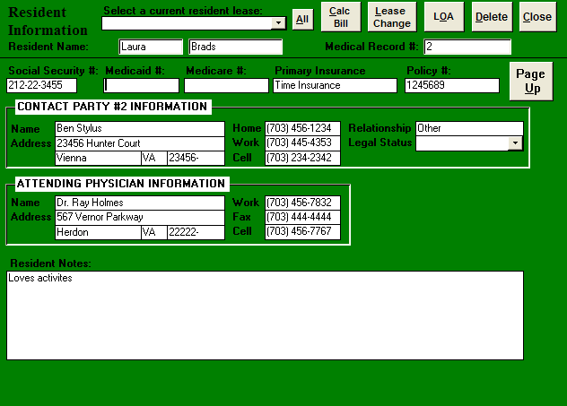
Exhibit 34: Resident Information - Page 2
Social Security #: The resident’s social security number.
Medicaid #: The resident’s Medicaid number.
Medicare #: The resident’s Medicare number.
Primary Insurance: The resident’s primary insurance carrier.
Policy #: The resident’s insurance policy number.
Contact Party #2 Information: Another person to contact in the event the first contact is unavailable. This person could be a family member, friend, etc. Fields are provided for the person’s address, relationship to resident, phone numbers and legal status.
Attending Physician: The resident’s primary physician, including address information and phone numbers.
Resident Notes: A field for any additional information you wish to record about the resident.
After the “Resident Information” form is completed, click the CLOSE button at the top of the first page of the form, or, if you want to add another resident, click the ADD button again. If you wish to delete the current resident record, click the DELETE button. Only use the DELETE button to delete erroneous resident records. Never use the DELETE button to discharge a resident.

Bill Calculation
To calculate the resident’s contract charges for a specific month, click the CALC BILL button to open the “Calculate Bill” form. Select the desired month from the drop-down list, and enter the desired year. Leap To automatically calculates the contract charges for the selected bill month and year.

Lease Change Options
When you click the LEASE CHANGE button, the “Lease Change Options” form appears.
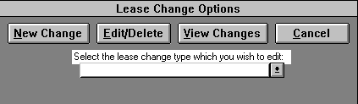
Exhibit 35: Lease Change Options
This form allows the user to record, edit, and review changes to the residents’ Room Numbers, Care Levels, and Rent Payment Types, the facility’s Unit Count and Resident Count, and any Lease Fields the user chooses (by clicking the box under “Track Changes?” on the “Resident Information” form).
Adding a Lease Change: To make a change to an existing lease, click the NEW CHANGE button. The “Adding Lease Change” form will appear.
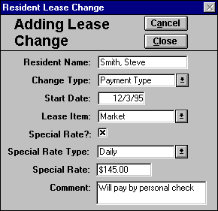
Exhibit 36: Adding Lease Change Form
To make a lease change, select a “Change Type” from the drop-down list. At the “Start Date” field, enter the date the change is to take effect. Choose the appropriate item change from the “Lease Item” drop-down list box. When you select a “Lease Item”, the default price will be in effect; if the lease change requires a different rate, click the “Special Rate” box and indicate whether the rate is daily or monthly, and the special rate amount. Finally, enter any comments that apply to the lease change. Press the CANCEL button to delete a mistakenly added lease change. The CLOSE button saves the lease change and exits the form.
Editing or Deleting a Lease Change: To edit or delete an existing Lease Change, click the EDIT/DELETE button and select a change from the drop-down list. Make the appropriate changes to the selected Lease Change in the “Edit/Delete Lease Change” form, and then click the CLOSE button to save your changes. To delete the selected Lease Change, click the DELETE button.
Viewing Lease Changes: Choosing the VIEW CHANGES button opens the “Resident Lease Change” report (Exhibit 46), which lists all the changes made to the current lease. You can change the order in which the changes are listed by using the Advanced Options Menu. To print a copy of the report, click the PRINT button. Click the CLOSE button to exit. Note: The “Resident Lease Change” report is a read-only report. No changes or deletions can be made on this screen.
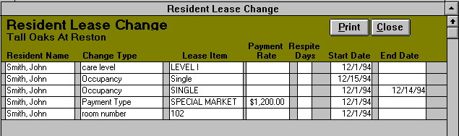
Exhibit 37: Resident Lease Change

Resident Face Sheet
Click this button to view a concise read-only report of the data collected through the “Resident Information” form. Choose a resident name from the “Select current resident lease” list box of current residents. If you wish to select from both past and present residents, click the ALL button (pressing the ALL button again brings back the current resident list). Click the PRINT button to print a copy of the resident face sheet. Select the CLOSE button to return to the “Resident and Employee Menu.”

Resident Discharge
Clicking on the RESIDENT DISCHARGE OPTIONS button opens the “Resident Discharge Options” form (Exhibit 47). Use this form to discharge residents or to edit the record of a previously discharged resident.
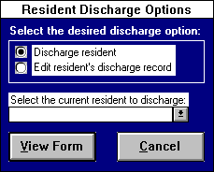
Exhibit 38: Resident Discharge Options

Discharging a Resident
Choose the ‘Discharge resident’ option and then select the resident you want to discharge from the drop-down list. Click the VIEW FORM button, and a new discharge record for the selected resident will appear.
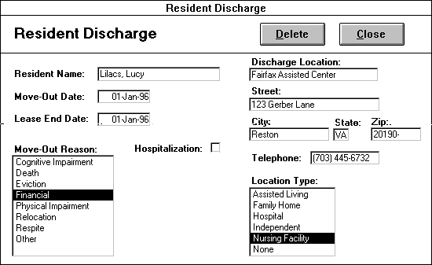
Exhibit 39: Resident Discharge form
Complete a resident’s discharge record by filling in the information according to the field descriptions below.
Resident Name: The program automatically inputs the resident’s name from the “Resident Discharge Options” form.
Move-Out Date: The date the resident is physically moved out of your facility.
Lease End Date: The date through which the resident is financially responsible for a unit.
Move-Out Reason: Select from the list provided.
Hospitalization: Click this box to indicate that the resident has been discharged to a hospital. A list box of local hospitals will appear. Choose the discharge hospital by pointing and clicking. To add a new hospital to the list, type in the hospital’s name in the list box, press enter, and choose YES at the message prompt.
Location type: Select the term that best describes the resident's new home.
Discharge Location (and address fields): Name and address of the location to which the resident has been discharged. For example, if the resident moved in with her daughter, you would choose "Family home" for location type, enter “Daughter’s home” in the “Discharge Location” field, and her daughter’s address and phone number in the address fields.
When all appropriate information has been entered in the “Resident Discharge” form, click CLOSE to save the information and exit. After a discharge record has been created, any lease changes due to start after the lease end date are automatically deleted and current lease changes are updated to end on the lease-end date.

Editing or Deleting a Discharge Record
Select the ‘Edit discharge record’ option to edit or delete a resident who has already moved out of the facility. After selecting the desired resident, click on the VIEW FORM button, make the appropriate changes, and click CLOSE to save your changes and exit. To delete a discharge record, simply click DELETE on the desired resident’s discharge record and click OK at the prompt. After a discharge record has been edited or deleted, any lease changes due to start after the lease end date are automatically deleted and current lease changes are updated to end on the lease-end date. [Note: If you press the DELETE button, the discharge record will be deleted, undoing the resident’s discharge and clearing the end dates on the most recent lease changes.]

Employee Information
This form lets you add, edit, and review employee information. When you click the EMPLOYEE INFORMATION button, the “Employee Information” form appears.
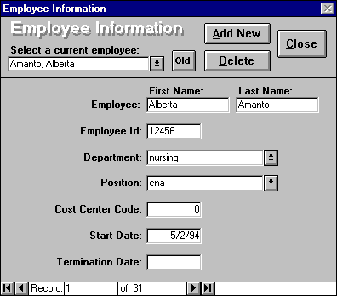
Exhibit 40: Employee Information

Adding a New Employee
To add a new employee to Leap To, click ADD NEW at the top of the “Employee Information” form and enter the employee name and additional information according to the field descriptions below:
Employee ID: Alphanumeric code assigned to an individual employee for identification (no two employees can share the same ID in Leap To.)
Department: Group of employees with similar responsibilities. Examples include Nursing, Food Service, Maintenance, etc.
Position: Employee’s job title.
Cost Center Code: Number indication the cost center to which the employee’s wages will be charged.
Start Date: Date of the employee’s first workday at your facility.
Termination Date: Date of the employee’s last workday at your facility. This field should be blank until an employee has either given notice that she is leaving or has been fired.
After all the employee information has been entered, click the CLOSE button to save the information and exit.

Editing Employee Information
View a desired employee’s information by selecting his name from the ‘Select current employee’ list box of current employees. (Current employees include all staff entered through this form that have either not been terminated or whose termination date occurs after today’s date. If you wish to view a terminated employee’s record, click the OLD button to reveal the ‘Select terminated employee’ list box. Pressing the OLD button again causes the ‘Select current employee’ box to reappear and ‘Select terminated employee’ box to disappear.) After the desired employee’s information appears, make the desired changes to the information, then click the CLOSE button to save the changes and exit. Selecting the DELETE button will delete the current employee record, but this button should only be used to remove erroneous employee records, such as an employee record entered twice. NEVER USE THE DELETE BUTTON TO TERMINATE AN EMPLOYEE. To terminate an employee, simply enter the date of the employee’s last workday in the “Termination Date” field. Clicking the CLOSE button exits this form and returns you to the “Resident and Employee Menu.”
Note: If you do not add new employees, they will not appear in any of your reports or forms, so this process is crucial.

Part VII

Facility Options Menu
This menu allows the coordinator(s) to enter general information about the facility required by the program. These forms should be completed before operating the program because many of the forms in Leap To require this information. [Note: You will not be able to access this menu without the appropriate security permissions.]
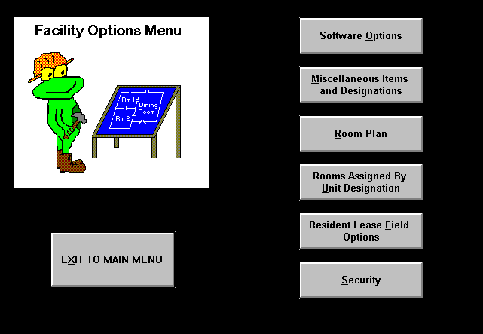
Exhibit 41: Facility Options Menu

Software Options
This form allows the care coordinator to specify some general options for the Health Leap program. Enter the requested information according to the following field descriptions.
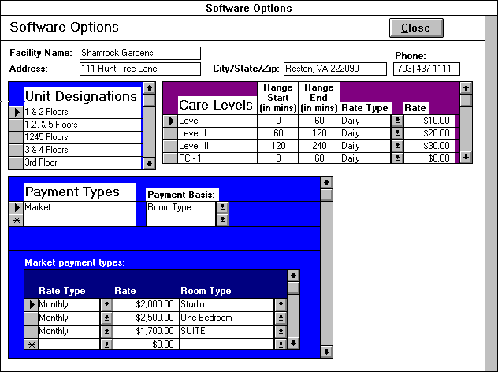
Exhibit 42: Software Options

Unit Designations
Enter any designations you wish to assign to groups of units or sections of your facility. For example, “wings” or “units.”

Care Levels
Define your facility’s care levels by amount of care and rate charged. Enter care level information according to the following field descriptions:
Range Start Time: The minimum amount of service time (in minutes) the facility will devote to a resident under the specified care level.
Range End Time: The maximum amount of service time (in minutes) the facility will devote to a resident under the specified care level.
Rate Type: Choose daily or monthly rate.
Rate: The amount of money to be charged for the specified care level.

Payment Types
Create and define different payment types for resident rent by associating payment types with one of three selections under “Payment Basis”: “Room Type”, “Flat Rate”, or “Special Rate.” Depending on the “Payment Basis” selected, the user may have to enter some or all of the following information under the “Individual payment types” heading:
Room Type: Specify a Rate Type (daily or monthly), Rate, and each Room Type for which the Payment Type will apply (Room Types are designated through the “Room Plan” form.) For example, if the user creates a Payment Type called “Market” which will be based on a resident’s Room Type, under “Market payment types” the user would assign each Room Type (“Studio”) to a Rate Type (“Monthly”) and Rate ($2000.00), etc.
Flat Rate: Specify a Rate Type and Rate.
Special Rate: This payment basis requires no additional entry. Special Rates are defined in the “Resident Lease Field Options” form.
After you have defined the Unit Designations, Care Levels, and Payment Types for your facility, click the CLOSE button to save your entries and exit.

Misc Items and Designations

The miscellaneous category is a catchall grouping which allows the coordinator additional flexibility to track those assignments, which do not fall in the employee, resident, or unit responsibility categories. In Miscellaneous Items By Designation form, the care coordinator creates the desired miscellaneous items and miscellaneous item designations.
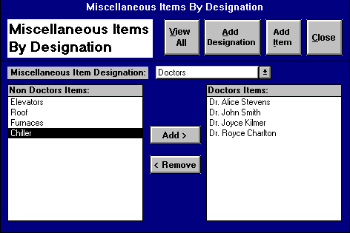
Exhibit 43: Miscellaneous Items By Designation
To create a miscellaneous item, click the ADD ITEM button to open the “Miscellaneous Items” form. Click the ADD NEW button to enter a new misc item record. To delete an item record, select it by clicking on the gray rectangle to the left of the field, then click the DELETE button or press the delete key on the keyboard. Click PRINT to print your miscellaneous items, or CLOSE to save your entries and exit back to the “Miscellaneous Items By Designation” form.
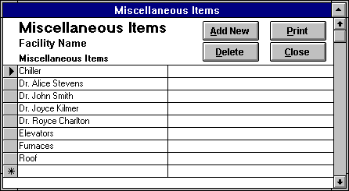
Exhibit 44: Miscellaneous Items
To create a miscellaneous item designation, click the ADD DESIGNATION button to open the “Miscellaneous Item Designations” form. Enter the new item designation in the blank field. To delete a designation, select it by clicking on the gray rectangle to the left of the field, then press the delete key on the keyboard. Press CLOSE to save your entries and exit back to the “Miscellaneous Items By Designation” form.
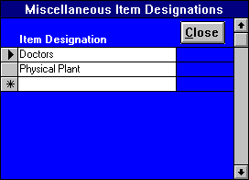
Exhibit 45: Miscellaneous Item Designations
Once the appropriate miscellaneous items and designations are created, then the misc item designations need to be defined by the coordinator. To assign misc items to a specific misc item designation, first select the desired misc item designation in the “Misc Item Designation” list box. (This list box includes all the miscellaneous item designation you created through the “Miscellaneous Item Designations” form, while the miscellaneous items are compiled from the “Miscellaneous Items” form.) On the left side of the form is a list of misc items not yet assigned to the selected “Miscellaneous Item Designation.” On the right side of the form is a list of misc items already assigned to the currently selected misc item designation. (When you initially assign misc items to a “Misc Item Designation”, this section of the form will be blank). You can add misc items to your item designations in either of two ways: single click the desired misc item and click the ADD button, or simply double click on the desired misc item. Removing misc items from an item designation works very similarly. You can either select the misc item and click the REMOVE button, or double click the unwanted misc item in the misc item designation list.
Press the VIEW ALL button to view and/or print all the miscellaneous item designations and items, which you have created. Click the CLOSE button to return to the “Facility Options Menu.”

Room Plan
In this form, the care coordinator enters the facility’s room plan. Room Plan is separated into the following two fields:
Room #: Number of the unit.
Room Type: The type of unit (i.e. Studio, Suite, and One Bedroom).
Click the ADD NEW button to enter a new room record. To delete a room record, select it by clicking on the gray rectangle to the left of the room number, then click the DELETE button or press the delete key on the keyboard. Click PRINT to print a copy of the Room Plan, or CLOSE to save your entries and exit. The “Room Plan” form allows the use of the Advanced Options Menu.
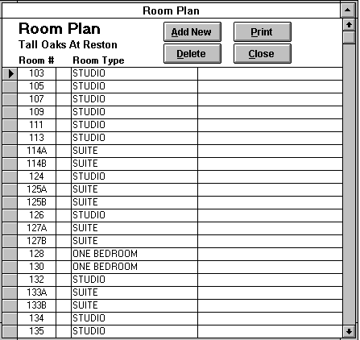
Exhibit 46: Room Plan

Rooms Assigned by Unit Designation
To assign rooms to a specific unit designation, first select the desired unit designation from the “Unit Designation” list box. (The unit designations in this list box are inputted through the “Software Options” form, while the room numbers are compiled from the “Room Plan” form. These two forms need to be completed before you can make your unit-designated room assignments.) On the left side of the form is a list of room numbers not yet assigned to any “Unit Designation.” On the right side of the form is a list of room numbers already assigned to the currently selected “Unit Designation” (when you initially assign room numbers to a “Unit Designation”, this section of the form will be blank). You can add rooms to your unit designations in either of two ways: single click the desired room number and click the ADD button, or simply to double click on the desired room number. Removing room numbers from a unit designation works very similarly. You can either select the room number or click the REMOVE button, or double click the unwanted room number in the unit room assignment list.
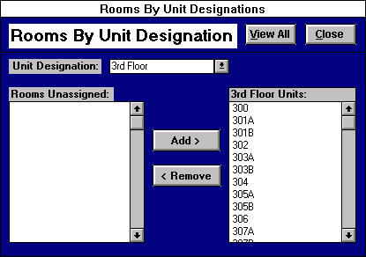
Exhibit 47: Room Assignments By Unit Designation
To view all the unit designations and their assigned room numbers together, simply click the VIEW ALL button to open the “Rooms Assigned By Unit Designation.” report (Exhibit 57). To print this report, click the PRINT button. Click the CLOSE button to save your entries and exit. The “Room Assignments By Unit Designation” form allows the use of the Sort Options Menu.
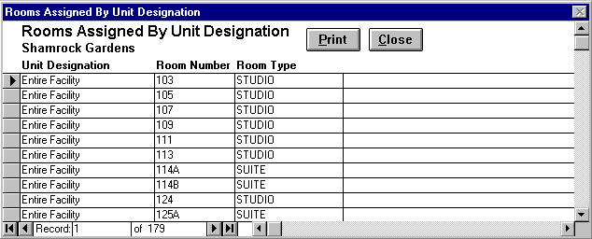
Exhibit 48: Rooms Assigned By Unit Designation

Resident Lease Field Options
This form allows the user to specify additional lease fields on the “Resident Information” form and to select which of these lease fields will be incorporated on the “Resident Face Sheet” form. Choose one of the following options:
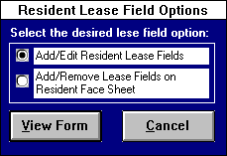
Exhibit 49: Resident Lease Field Options

Add/Edit Resident Lease Fields
Selecting this option opens the “Resident Lease Fields” form.
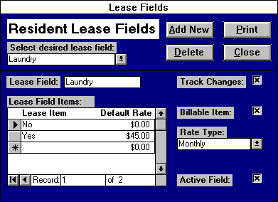
Exhibit 50: Resident Lease Fields
Use this form to specify any additional information you wish to track for your resident by creating “Lease Fields” to appear on the “Resident Information” form. To enter a new resident lease field, simply click the ADD NEW button and enter the appropriate information according to the following field descriptions:
Lease Field: Enter a field name (for example, “Religion”.)
Lease Field Items: Input the list of options the user has to choose from when entering information for the lease field. If the lease field is a billable item, the user can supply default rates for each lease item. (For example, the Lease Field “Religion” could contain the Items “Catholic”, “Hindu”, “Lutheran” An example of some lease field items would be Catholic, Protestant, Jewish, Muslim, and Other for the lease field Religion.) Some lease fields, such as addresses, will not have any lease field items since the information collected will be unique for each resident.
Track Changes: Click an “X’ in this box if you wish to track changes in information for each resident for the selected lease field. The changes are tracked through the “Lease Change Options” form accessed through the “Resident Information” form.
Billable Item: Click an “X’ in this box if the selected lease field is a billable item for your facility. For the billable item lease fields, the user should supply default rates for each lease item. For billable item lease fields, the lease field changes should always be tracked.
Rate Type: This field only appears if the billable item box is marked with an “X”. The user specifies whether the lease field is billed at a daily or monthly rate.
Active Field: Indicates that a lease field is currently active. This box is marked with an ‘X’ by default. Only active lease fields are included in the lease field lists in the “Resident Information” and “Resident Face Sheet Lease Field Selection” forms. When this box is unmarked, a lease field becomes inactive and is dropped from the lists.
Clicking on the DELETE button will delete the selected lease field. Deactivating the lease field by unmarking the “Active” box will allow you to reactivate the information at a later time, eliminating possible repeated entry. Press the PRINT button to print the Lease Fields Report and the CLOSE button to return to the “Facility Options Menu.”

Add/Remove Lease Fields on the Resident Face Sheet
Selecting this option opens the “Resident Face Sheet Lease Field Selection” form, which allows the user to determine which Lease Fields appear on the Resident Face Sheet under the heading “Other Information”.
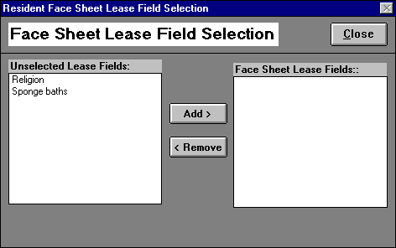
Exhibit 51: Face Sheet Field Selection
Fields listed under “Unselected Lease Fields” are not currently included in the Resident Face Sheet; fields listed under “Face Sheet Lease Fields” currently appear on the Resident Face Sheet. The user can add “Unselected Lease Fields” to the Face Sheet by clicking on the desired Field then clicking the ADD button, or by simply double-clicking on the desired Field. Remove “Face Sheet Lease Fields” from the Face Sheet by clicking on the desired Field then clicking the ADD button, or by simply double-clicking on the desired Field. Pressing the CLOSE button returns you to the “Facility Options Menu.”
Clicking the VIEW FORM button will open the form associated with the selected option while pressing the CANCEL button returns the care coordinator to the “Facility Menu.”

Security Options
This form, accessed through the “Facility Options Menu,” allows the care coordinator to set Leap To’s security. User security determines access to Leap To and its objects. A user name and password are required each time the program is opened.
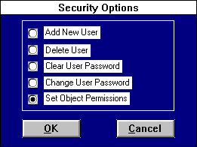
Exhibit 52: Security Options

Add New User
The "Add New User" form allows the user that belongs to the coordinators group to create a new account for a new user. Specify the following information:
New User Name: An alphanumeric string that identifies each user account. Any combination of letters and numbers can be used in this field, including the new user’s name.
User Group: Identifies both the type of a user and the permissions granted to that user; choose from “Coordinators”, “Supervisors” and “Staff.” For example, users who belong to a group the coordinators group are allowed to create new accounts and delete old ones, but users that belong to other groups are not allowed to add or delete accounts.
Personal Identifier (PID): A case-sensitive alphanumeric string 4-20 characters long that Leap To uses to distinguish each user in a Workgroup. This identifier can be the same as the user name or the password, but needs to be unique to each user. For example, if two Jennifers work at your facility, both can have the user name “Jennifer”, but they should have different PIDs and passwords.
New Password: A case-sensitive alphanumeric string used for logging into the database. Passwords should contain at least five characters and be easy to remember but difficult to guess. Keeping the password private prevents a security breach and makes tracking much easier.
Verify: Confirms a new password by prompting you to retype the alphanumeric string you have just created.
After the new password is verified, click OK and the new account will be created. Click CANCEL to exit the form without creating a new account. After a new account is created, the new user will be able to login to the database with the new user name and password.
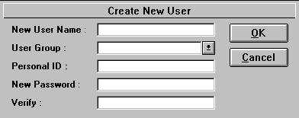
Exhibit 53: Create New User

Delete User
"Delete User" allows a coordinator to delete a user account. To delete a user account, choose a user name from the drop-down list and click OK. Click CANCEL to exit without deleting a user. [Note: Once a user is deleted, the user name, PID, group, and password cannot be retrieved.]
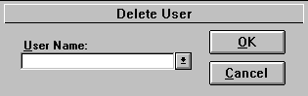
Exhibit 54: Delete User

Clear User Password
The "Clear User Password" form enables the users that belong to the coordinators group to clear a user password of a user. This is used in case the user(s) forgot his or her password and wants to regain access to Date Leap. The coordinator can then clear the password through this form and then create a new password for the user through the “Change Password” form.
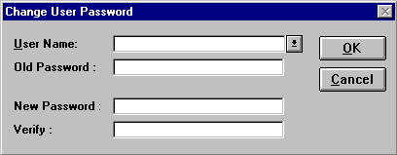
Exhibit 55: Clear User Password
Choose a user name from the drop-down list and click the CLEAR PASSWORD button. Click CANCEL to exit the form without clearing the password. Once the password is cleared, the user (or the coordinator) should enter a new password by utilizing the “Change User Password” form. By reducing the number of no-password accounts, the system maintains a higher level of security.

Change User Password
This form allows the coordinator to change a password to a user account. Enter the old password, then enter the new password and verify it. If a new password is being entered to replace a password that has been cleared (see above), then leave the “Old Password” field blank. Click the OK button to accept the new password. Click CANCEL to exit the form without saving your changes. Passwords should have at least five characters (letters or numbers), which prove easy to remember but difficult to guess.
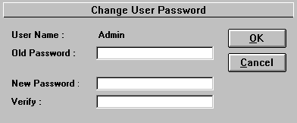
Exhibit 56: Change User Password
Use the Change User Password feature as often as you like. The password is like a key; it’s the user's responsibility to keep that key safe.

Set Tickler Object Permissions
This form allows members of the coordinators group to set object permissions for each menu object.
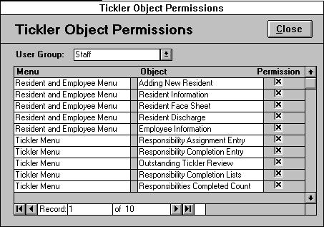
Exhibit 57: Tickler Object Permissions
Select a user group from the drop-down list box and click an “X” in the permission boxes of those menu objects you want the selected user group to be able to view. Conversely, unmark the permission boxes of those menu objects you do not want the selected user group to view. Click CLOSE to return to the “Security Options” form.

Option Menus
Many of Leap To’s forms support Sort Options and Advanced Options menus. These option menus appear at the top left-hand corner of most continuous forms (forms showing a list of records instead of one record at a time). To access these menus, click on the menu heading, choose the desired option from the menu, then point and click with your mouse. The two types of menus and their commands are explained below:

Sort Options Menu

Sort Ascending
Sort the records of the current field in ascending order (alphabetically or numerically). For example, in the “Rooms Assigned by Unit Designation” form, click anywhere in the “Unit Designation” column, click on Sort Options, and select Ascending Order. All records in the “Rooms Assigned by Unit Designation” form will be sorted in ascending alphabetical order by “Unit Designation.”

Sort Descending
This will sort the records of the current field in descending order (alphabetically or numerically). For example, in the “Rooms Assigned by Unit Designation” form, click anywhere in the “Room Number” column, click on Sort Options, and select Descending Order. All records in the “Rooms Assigned by Unit Designation” form will be sorted in descending order by room number.

Copy
This command will copy the selected text to the Windows clipboard, which can be later retrieved using the Paste command in this or another Windows application. This command is utilized when the user wants to copy information to another place within the program or to export selected information to another application. To select the data you wish to copy, click the left mouse button and hold it down as you drag the cursor over the desired text. Release the mouse button when all the desired text has been highlighted and click the Copy command.

Paste
This command will take the text previously copied onto the Windows clipboard and paste it into the currently selected location. This command saves the user from having to retype the same information into another application.

Help
Clicking Help will display the Health Leap context-sensitive help file, which will open on the topic that your cursor rests on. For example, you can press the Help command on “Resident Information”, and the help file will pop up with information concerning this form. You can also access this command by pressing the F1 key.

Advanced Options
The Advanced Options menu supports the same options as the Sort Options menu, plus the following options:

Datasheet View
This will switch the form to Datasheet View. Datasheet View displays a form’s information in a columnar format similar to spreadsheet applications like Excel, making the data easier to manipulate. To select all of a columns and records in a form, click on the small gray box to the left of the first column title. To select a particular column, click on the column title. The user can select multiple columns by clicking the column title and holding the mouse button down while dragging the pointer over the column titles. Release the mouse button when you have selected the desired columns. Another method for selecting multiple columns requires you to hold down the Shift key and click on the column titles of the columns you wish to select. Once a column(s) is selected, the user can move the selected column(s) by clicking on the column title, while holding the mouse button down and dragging the pointer to where he/she wishes to move the column(s). The user also has the option of selecting a record or records by clicking on the record selectors, the small gray boxes to the left of each record. Multiple records can be selected by using either the Shift key or drag and release method. Once the desired data is selected, the user can use the Copy command to copy the data to the Windows Clipboard for use in another application.

Form View
This is the default view of a form. To return to this view from Datasheet View, the user clicks on the Form View command.

Table of Exhibits
Exhibit 1: Buttons 7
Exhibit 2: Fields 7
Exhibit 3: Filters 8
Exhibit 4: Main Menu 9
Exhibit 5: Work Order Entry 11
Exhibit 6: Equipment 14
Exhibit 7: Maintenance List 16
Exhibit 8: Work Order Reports 17
Exhibit 9: Outstanding Work Orders 18
Exhibit 10: Work Order Detail 19
Exhibit 11: Reimbursable Work Orders 21
Exhibit 12: Contracted Work Orders 22
Exhibit 13: Equipment Reports 24
Exhibit 14: Equipment Detail 24
Exhibit 15: Equipment Detail (no notes) 26
Exhibit 16: Responsibility Tickler Menu and Buttons 27
Exhibit 17: Responsibility Assignment Form 28
Exhibit 28: Top Section: Responsibility Assignment Form 29
Exhibit 29: Middle Section: Responsibility Assignment Form 30
Exhibit 30: Item Types Form 31
Exhibit 31: Bottom Section: Responsibility Assignment Form 32
Exhibit 32: Responsibility Completion Entry 33
Exhibit 33: Outstanding Tickler Review Options 35
Exhibit 34: Outstanding Tickle Review: Employee Responsibilities 36
Exhibit 35: Report Specific Filters: Employee Outstanding Responsibilities 37
Exhibit 36: Responsibility Completion Reports: Option Box 38
Exhibit 37: Employee Responsibility Completion List 39
Exhibit 38: Responsibilities Completed Count Options 40
Exhibit 39: Resident Completed Responsibilities Count 41
Exhibit 40: Resident and Employee Menu 43
Exhibit 41: Adding New Resident 44
Exhibit 42: Resident Information - Page 1 44
Exhibit 43: Resident Information - Page 2 46
Exhibit 44: Lease Change Options 47
Exhibit 45: Adding Lease Change Form 47
Exhibit 46: Resident Lease Change 48
Exhibit 47: Resident Discharge Options 49
Exhibit 48: Resident Discharge form 49
Exhibit 49: Employee Information 51
Exhibit 50: Facility Options Menu 53
Exhibit 51: Software Options 54
Exhibit 52: Miscellaneous Items By Designation 56
Exhibit 53: Miscellaneous Items 56
Exhibit 54: Miscellaneous Item Designations 57
Exhibit 55: Room Plan 58
Exhibit 56: Room Assignments By Unit Designation 59
Exhibit 57: Rooms Assigned By Unit Designation 59
Exhibit 58: Resident Lease Field Options 60
Exhibit 59: Resident Lease Fields 60
Exhibit 60: Face Sheet Field Selection 61
Exhibit 61: Security Options 62
Exhibit 62: Create New User 63
Exhibit 63: Delete User 63
Exhibit 64: Clear User Password 64
Exhibit 65: Change User Password 64
Exhibit 66: Tickler Object Permissions 65

